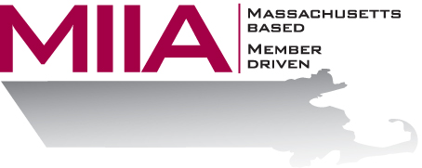
MIIA Professional Development Training

Managing Millennials

February 25, 2016
2:00-3:00 PM

Every generation has its own personality, and millennials are no exception. Innovative and highly-autonomous, they often have difficulty following rules, a problem for employers. This webinar will look at millennials, their values, and what motivates them, with an eye towards developing positive work relationships.

About the Presenter:
Cally Ritter is an EAP consultant with AllOne Health EAP, and a Licensed Independent Clinical Social Worker. She has a B.A. from Bucknell University, a master of social work from the University of Pittsburgh, and twenty years of clinical experience in a variety of settings, including inpatient and outpatient services in Philadelphia, Pittsburgh and Boston. Cally has been an EAP trainer for more than ten years, and has presented on a variety of personal and professional development topics. Her areas of interest include the multigenerational workplace, resiliency and employee motivation. She infuses her seminars with energy, examples, exercises, and content excellence.

To register:
Please go to the following link and complete the required information:
https://attendee.gotowebinar.com/register/8803393050094816769
After registering, you will receive an email containing webinar access details. See you there!

