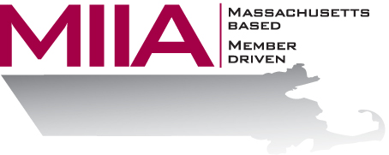
MIIA Professional Development Training

Managing Multiple Priorities
May 4, 2017
2:00-3:00 PM

Do you need to get more done with less times and resources? If you’re like most employees, you’re juggling multiple projects and deadlines every day, just hoping not to drop the ball. While most of us don’t have the job title Project Manager, we must still manage multiple priorities and responsibilities. Attend this session to explore how to eliminate time wasters, set priorities, stay on task and on time, goal set, manage multiple bosses (stakeholders), and manage the unexpected with confidence and calm.

About the Presenter:
Cally Ritter is an EAP consultant with AllOne Health EAP, and a Licensed Independent Clinical Social Worker. She has a B.A. from Bucknell University, a master of social work from the University of Pittsburgh, and twenty years of clinical experience in a variety of settings, including inpatient and outpatient services in Philadelphia, Pittsburgh and Boston. Cally has been an EAP trainer for more than ten years, and has presented on a variety of personal and professional development topics. Her areas of interest include the multigenerational workplace, resiliency and employee motivation. She infuses her seminars with energy, examples, exercises, and content excellence.

To register:
Please go to the following link and complete the required information:
https://attendee.gotowebinar.com/register/6346684958374121732
After registering, you will receive an email containing webinar access details. See you there!

