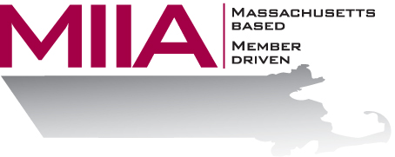

Thriving Through Municipal Transition
September 30, 2015
2:00-3:00 PM

We live in an era of major change, and municipalities are not immune to that. In this webinar, we will explore tips and strategies for keeping pace with all the changes we see in today’s municipal workplace, including changes in technology and diversity, as well as the general pace at which business moves today and its increased pressures. We’ll also consider the challenge and excitement of managing change in general.

About the Presenter:
Cally Ritter is an EAP consultant with AllOne Health EAP, and a Licensed Independent Clinical Social Worker. She has a B.A. from Bucknell University, a master of social work from the University of Pittsburgh, and twenty years of clinical experience in a variety of settings, including inpatient and outpatient services in Philadelphia, Pittsburgh and Boston. Cally has been an EAP trainer for more than ten years, and has presented on a variety of personal and professional development topics. Her areas of interest include the multigenerational workplace, resiliency and employee motivation. She infuses her seminars with energy, examples, exercises, and content excellence.

To register:
Please go to the following link and complete the required information: https://attendee.gotowebinar.com/register/392455650744081922 After registering, you will receive an email containing webinar access details. See you there!

