Winter Weather Slip and Fall Prevention

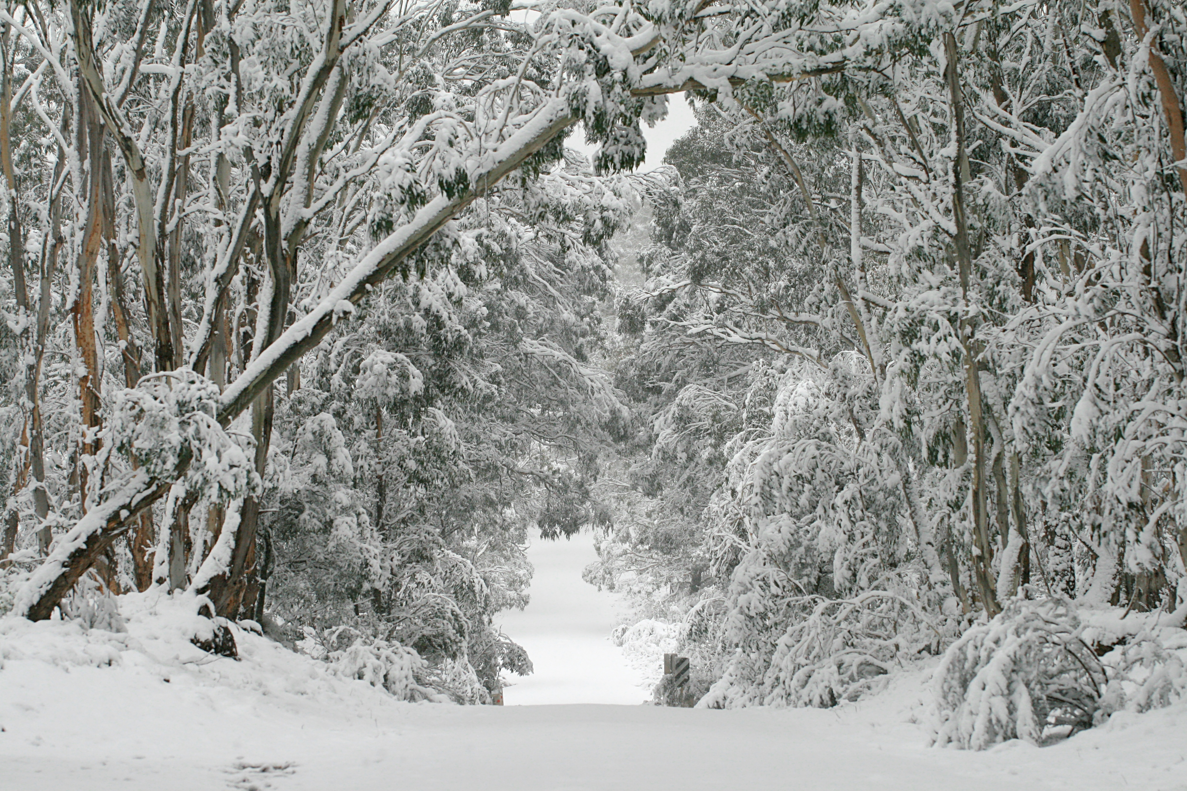

Snowy and Icy conditions can cause an increase risk of Back Injuries, Slips and Falls
that can result in serious injury and sometimes even death.

DATE: Thursday, January 28, 2021

TIME: 12:00 p.m. – 1:00 p.m.

The overall purpose of this MIIA training is to:

Motivate and assist town managers, DPW employees, school administration, faculty, custodial and facilities service staff to reduce their personal risks of back injuries, slips, trip and falls that are often the result of preventable causes, especially during extreme winter weather conditions. Personal risks include: improper winter foot wear and clothing (use proper PPE), poor planning, balance and judgment, rushing, improper snow and ice removal, unsafe working/walking surfaces, and poor lifting techniques. Employee education regarding slip and fall prevention, back care, and best practice snow removal methods and lifting techniques will be the focus of this MIIA winter safety class.

Safety Training handouts will include:

- 8 Tips for Staying Safe this Winter
- Office ergonomic tips and learning the anatomy of a healthy and strong back
- Therapeutic back and core exercises/ postures to prevent and relieve back aches
- Guidelines for good body mechanics and safe lifting techniques
- Pre-work stretching guidelines and routines for employees


8 Best Practice Winter Tips for Avoiding a Slip or fall:

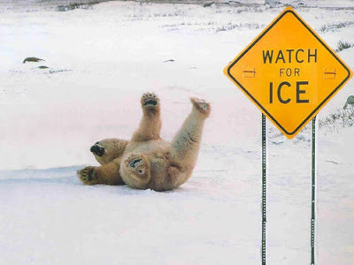

- Select and use proper snow removal equipment. The proper tools for the job are most important.

- Supply yourself with plenty of ice-melt or sand and spread generously on walkways, stairs and driveways.
Especially plan ahead, as well as during and after winter storms and nightly freeze over’s. Do not be surprised by New England’s ever changing weather conditions. Focus on looking ahead of storms and watching the nightly weather forecasts.

- Avoid climbing on ladders at all during snowy, windy and icy conditions. Do not climb on to a roof to clear ice dams or snow. Use a roof rake instead.

- Go slow, and proceed very couscously when walking on ice or when carrying things on stairs, walkways or slippery driveways. Use a hands free method and handrails (when available).

- Wear warm, supportive and slip resistant work shoes or boots.
Stomp through snow like Big Foot or else walk slowly shuffling your feet like Tim Conway from the Carol Burnett show.

- Carry things on your shoulder or use backpack with lumbar support when needed keeping at least one hand free. Use a shoulder strap to help keep your hands free in case of a sudden fall.

- Choose to push wet and heavy snow with plow, shovel or good snow thrower. Push with your Legs, and keep your back upright and straight.

- Always make personal safety your number 1 priority! Set a goal this winter to be “safer”. And be sure to work,” Smarter Not Harder” this winter and to stay Well-Aware of your abilities and risks.

