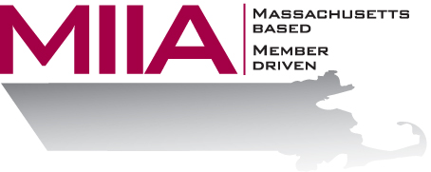
MIIA Professional Development Training

Working with Constructive Feedback
March 15, 2018
2:00-3:00 PM

Few people enjoy receiving “negative feedback”, yet feedback itself is so critical to growth and success. How can we take in feedback without getting defensive, and how do we actually learn from it?
This webinar will provide strategies such as: separating our ‘emotional response’ from our ‘reason-based response’, asking the feedback giver for further clarification, not getting swallowed up by the use of certain words, and seeing feedback as a gift rather than an obstacle.

About the Presenter:
Steven Bernstein is an Account Manager at AllOne Health EAP, where he provides organizational support to varied client organizations. Steven has been in the mental health and employee assistance fields for over a decade, having worked in various clinical settings. Most recently, Steven has sought to combine his clinical and business interests through the EAP field. In his work, Steven looks to offer compassionate and effective solutions for various employee assistance challenges.

To register:
Please go to the following link and complete the required information:
https://attendee.gotowebinar.com/register/6972747985401015553
After registering, you will receive an email containing webinar access details. See you there!

