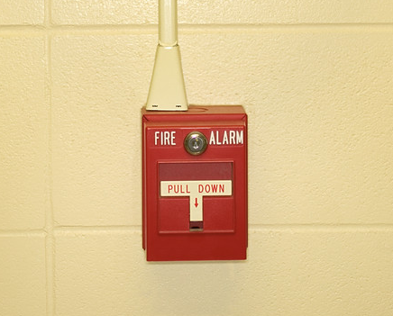
1.800.451.1834
Presented by your Employee Assistance Program, offered through AllOne Health
Critical Incidents:
Developing Your Crisis Management Skills

Seventy percent of adults in the U.S. will experience at least one traumatic event in their lives. We go to work each day expecting to be safe.
When a trauma occurs in the workplace, our sense of safety can be shattered. In the aftermath, employees need supportive leadership.
This seminar will provide managers with tools for navigating the workplace
after a traumatic event, and techniques for handling their own feelings and emotions.

MIIA Professional Development Training

Date:
April 14, 2016

Time:
11:00am-12:30pm

Presenter:
Cally Ritter

Location:
Community Center
100 Oak Street
Harwich, MA 02645

Location:
Paula Champagne
Health Director,
Employee Wellness pchampagne@town.harwich.ma.us

To Register:
Go to www.emiia.org and
click on “Training Calendar”

