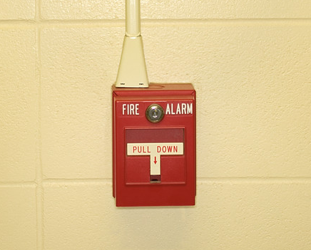
1.800.451.1834
Presented by your Employee Assistance Program, offered through AllOne Health
Critical Incidents:
Developing Your Crisis Management Skills

Seventy percent of adults in the U.S. will experience at least one traumatic event in their lives. We go to work each day expecting to be safe.
When a trauma occurs in the workplace, our sense of safety can be shattered. In the aftermath, employees need supportive leadership.
This seminar will provide managers with tools for navigating the workplace
after a traumatic event, and techniques for handling their own feelings and emotions.

MIIA Professional Development Training

Date:
June 22, 2016

Time:
10:00am-11:00am

Presenter:
Steven Bernstein, CEAP

Location:
Memorial Library
Large Conference Room,
Second Floor
175 Middlesex Ave.
Wilmington, MA

To Register:
Go to www.emiia.org and
click on “Training Calendar”

