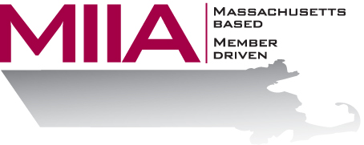
MIIA Professional Development Training

Customer Service in High Conflict
March 24, 2016
2:00-3:00 PM

For municipal employees, having to keep a smile on your face 24/7 can be tough, especially for departments that incur the most tension from residents. In this webinar, we will look at how to keep your cool and maintain your professionalism in the face of interpersonal adversity or tension.

About the Presenter:
Cally Ritter is an EAP consultant with AllOne Health EAP, and a Licensed Independent Clinical Social Worker. She has a B.A. from Bucknell University, a master of social work from the University of Pittsburgh, and twenty years of clinical experience in a variety of settings, including inpatient and outpatient services in Philadelphia, Pittsburgh and Boston. Cally has been an EAP trainer for more than ten years, and has presented on a variety of personal and professional development topics. Her areas of interest include the multigenerational workplace, resiliency and employee motivation. She infuses her seminars with energy, examples, exercises, and content excellence.

To register:
Please go to the following link and complete the required information:
https://attendee.gotowebinar.com/register/5728205262252016385
After registering, you will receive an email containing webinar access details. See you there!

