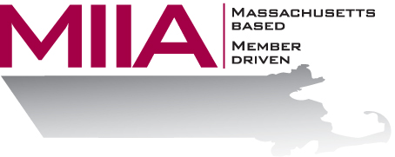
MIIA Professional Development Training

De-Escalation & Code of Conduct
October 19, 2017
2:00-3:00 PM

It’s no secret that getting along with the public is often a challenge in the municipal environment. In this webinar, we will explore key strategies for de-escalating high-conflict situations, while also looking at the value of a Code of Conduct in helping reinforce appropriate behavior among patrons - thus helping alleviate those difficult situations.

About the Presenters:
Steven Bernstein is an Account Manager at AllOne Health EAP, where he provides organizational support to varied client organizations. Steven has been in the mental health and employee assistance fields for over a decade, having worked in various clinical settings. Most recently, Steven has sought to combine his clinical and business interests through the EAP field. In his work, Steven looks to offer compassionate and effective solutions for various employee assistance challenges.

Marianne C. Fleckner has been in the Human Resources field for 30 years. Since 2008, she has been the Director of Human Resources for the Town of Acton. Before joining Acton, Marianne worked for the Commonwealth for over 20 years in various administrative capacities, specializing in classification & compensation and Agency mergers. She worked directly for five Governors, serving in such capacities as Chief Secretary and Deputy Commissioner. She sat on the Governor’s team to create a Zero Tolerance Workplace Violence policy for all State employees. Previous to joining the Commonwealth, Marianne worked in private industry. She received her Bachelor’s Degree in Business Management from Westfield State University and a Masters level certificate in Human Resources Management from Bentley University. Marianne is involved with a number of organizations, such as the Domestic Violence Services Network, The Center for Hope and Healing, Acton/Boxborough Rotary Club, Westford J.V. Fletcher Library, and the Massachusetts Commission on the Status of Women.

To register:
Please go to the following link and complete the required information:
https://attendee.gotowebinar.com/register/230534987294833665
After registering, you will receive an email containing webinar access details. See you there!

