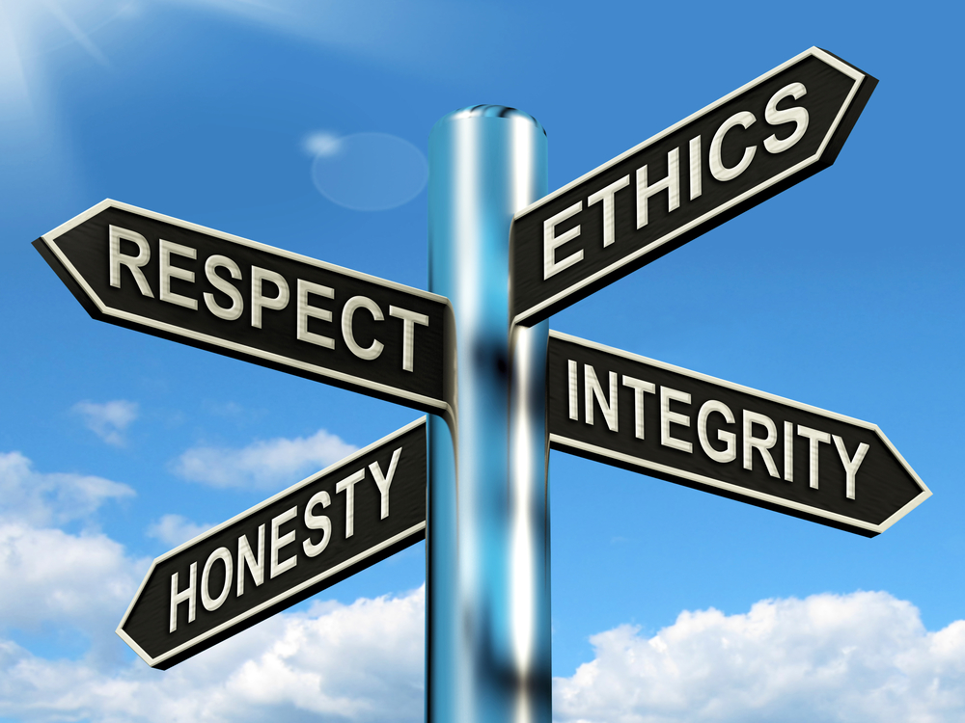
1.800.451.1834
Presented by your Employee Assistance Program, offered through AllOne Health
In the municipal environment, employees may sometimes find themselves in the midst of a conflict with a patron, third party or co-worker. Left unchecked, such disputes can pretty quickly become hostile, derailing employees from providing their invaluable service and stripping the environment of morale. Here we’ll look at a number of invaluable de-escalation techniques for helping calm self and other. But, we’ll also look at what’s involved in creating a municipal Code of Conduct to help establish the appropriate expectable behaviors for residents/others when in a municipal environment, as a means of preempting conflict and helping ensure safety and predictability for all.

De-escalation & Code of Conduct
MIIA Professional Development Training

Date:

Thursday, August 15th

Time:

2:00-3:00pm

Presenter:

Steven Bernstein, LMHC
with guest facilitator

Registration URL:

https://attendee.gotowebinar.com/register/8799821858886711553

