1.800.451.1834
From time to time, we all have to collaborate with people that we find challenging. What we want to say, and what we should say, are often two very different things. The “challenge” is to control our own response and utilize strategies that help to diffuse and resolve the situation. Participants in this seminar will learn and practice specific techniques for dealing with difficult people and situations.

Presented by your Employee Assistance Program, offered through AllOne Health
Dealing with Difficult People:
Enhancing Your Interpersonal Skills

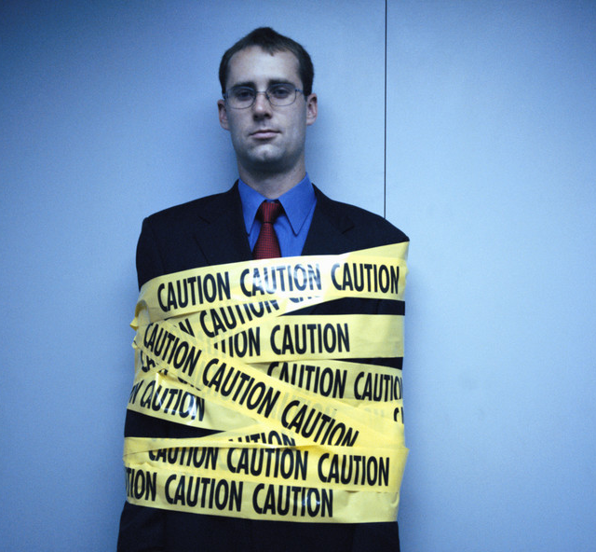
Date:
September 20, 2016

Time:
11:00am-12:00noon

Presenter:
Steven Bernstein, CEAP

Location:
160 Patriots Road
East Templeton, MA 01438

Contact:
Alisha O’Malley
HR Coordinator
HRadmin@templeton1.org
978-894-2756

To Register:
Go to www.emiia.org and
click on “Training Calendar”

MIIA Professional Development Training

