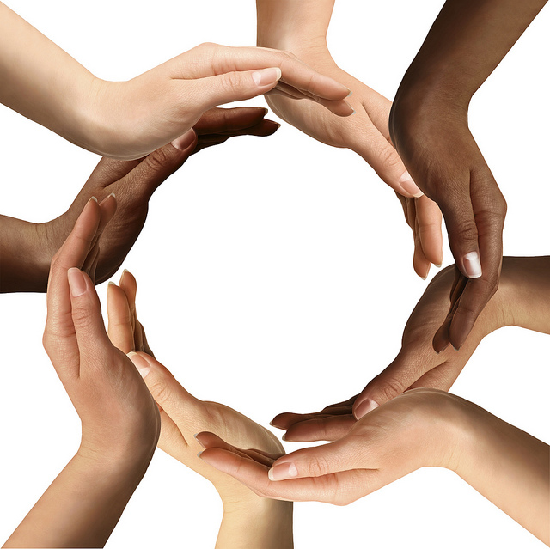

1.800.451.1834

Presented by your Employee Assistance Program, offered through AllOne Health

Diversity and Cultural Awareness

Why does cultural sensitivity matter to us today? The face of the world is changing, and we must identify and appreciate these changes in order to function effectively in a multicultural environment. This seminar will define cultural awareness and culture, offer compelling facts about today’s changing cultural landscape, address the unique psychological challenges associated with building cultural awareness, and provide tools for participants to enhance their cultural awareness.

MIIA Professional Development Training

Date:

Thursday, January 10th

Time:

2:00-3:00pm

Presenter:

Daphney Valcinor

Registration URL:

https://attendee.gotowebinar.com/register/7730013537733477377

