1.800.451.1834
Presented by your Employee Assistance Program, offered through AllOne Health
DOT Drug and Alcohol Training for Managers
and Supervisors
The purpose of the DOT regulations is “to prevent, through deterrence and detection, alcohol and controlled substance users
from performing safety-sensitive functions.” Managers and supervisors must be keen observers and use constructive confrontation to deal with this volatile issue and comply with DOT regulations. Participants in this seminar will learn how to recognize signs of substance abuse as job and performance problems and DOT violations, constructively address these problems with employees, identify employee appearance and behaviors that trigger reasonable suspicion drug tests, and implement
the organization’s substance abuse policies.
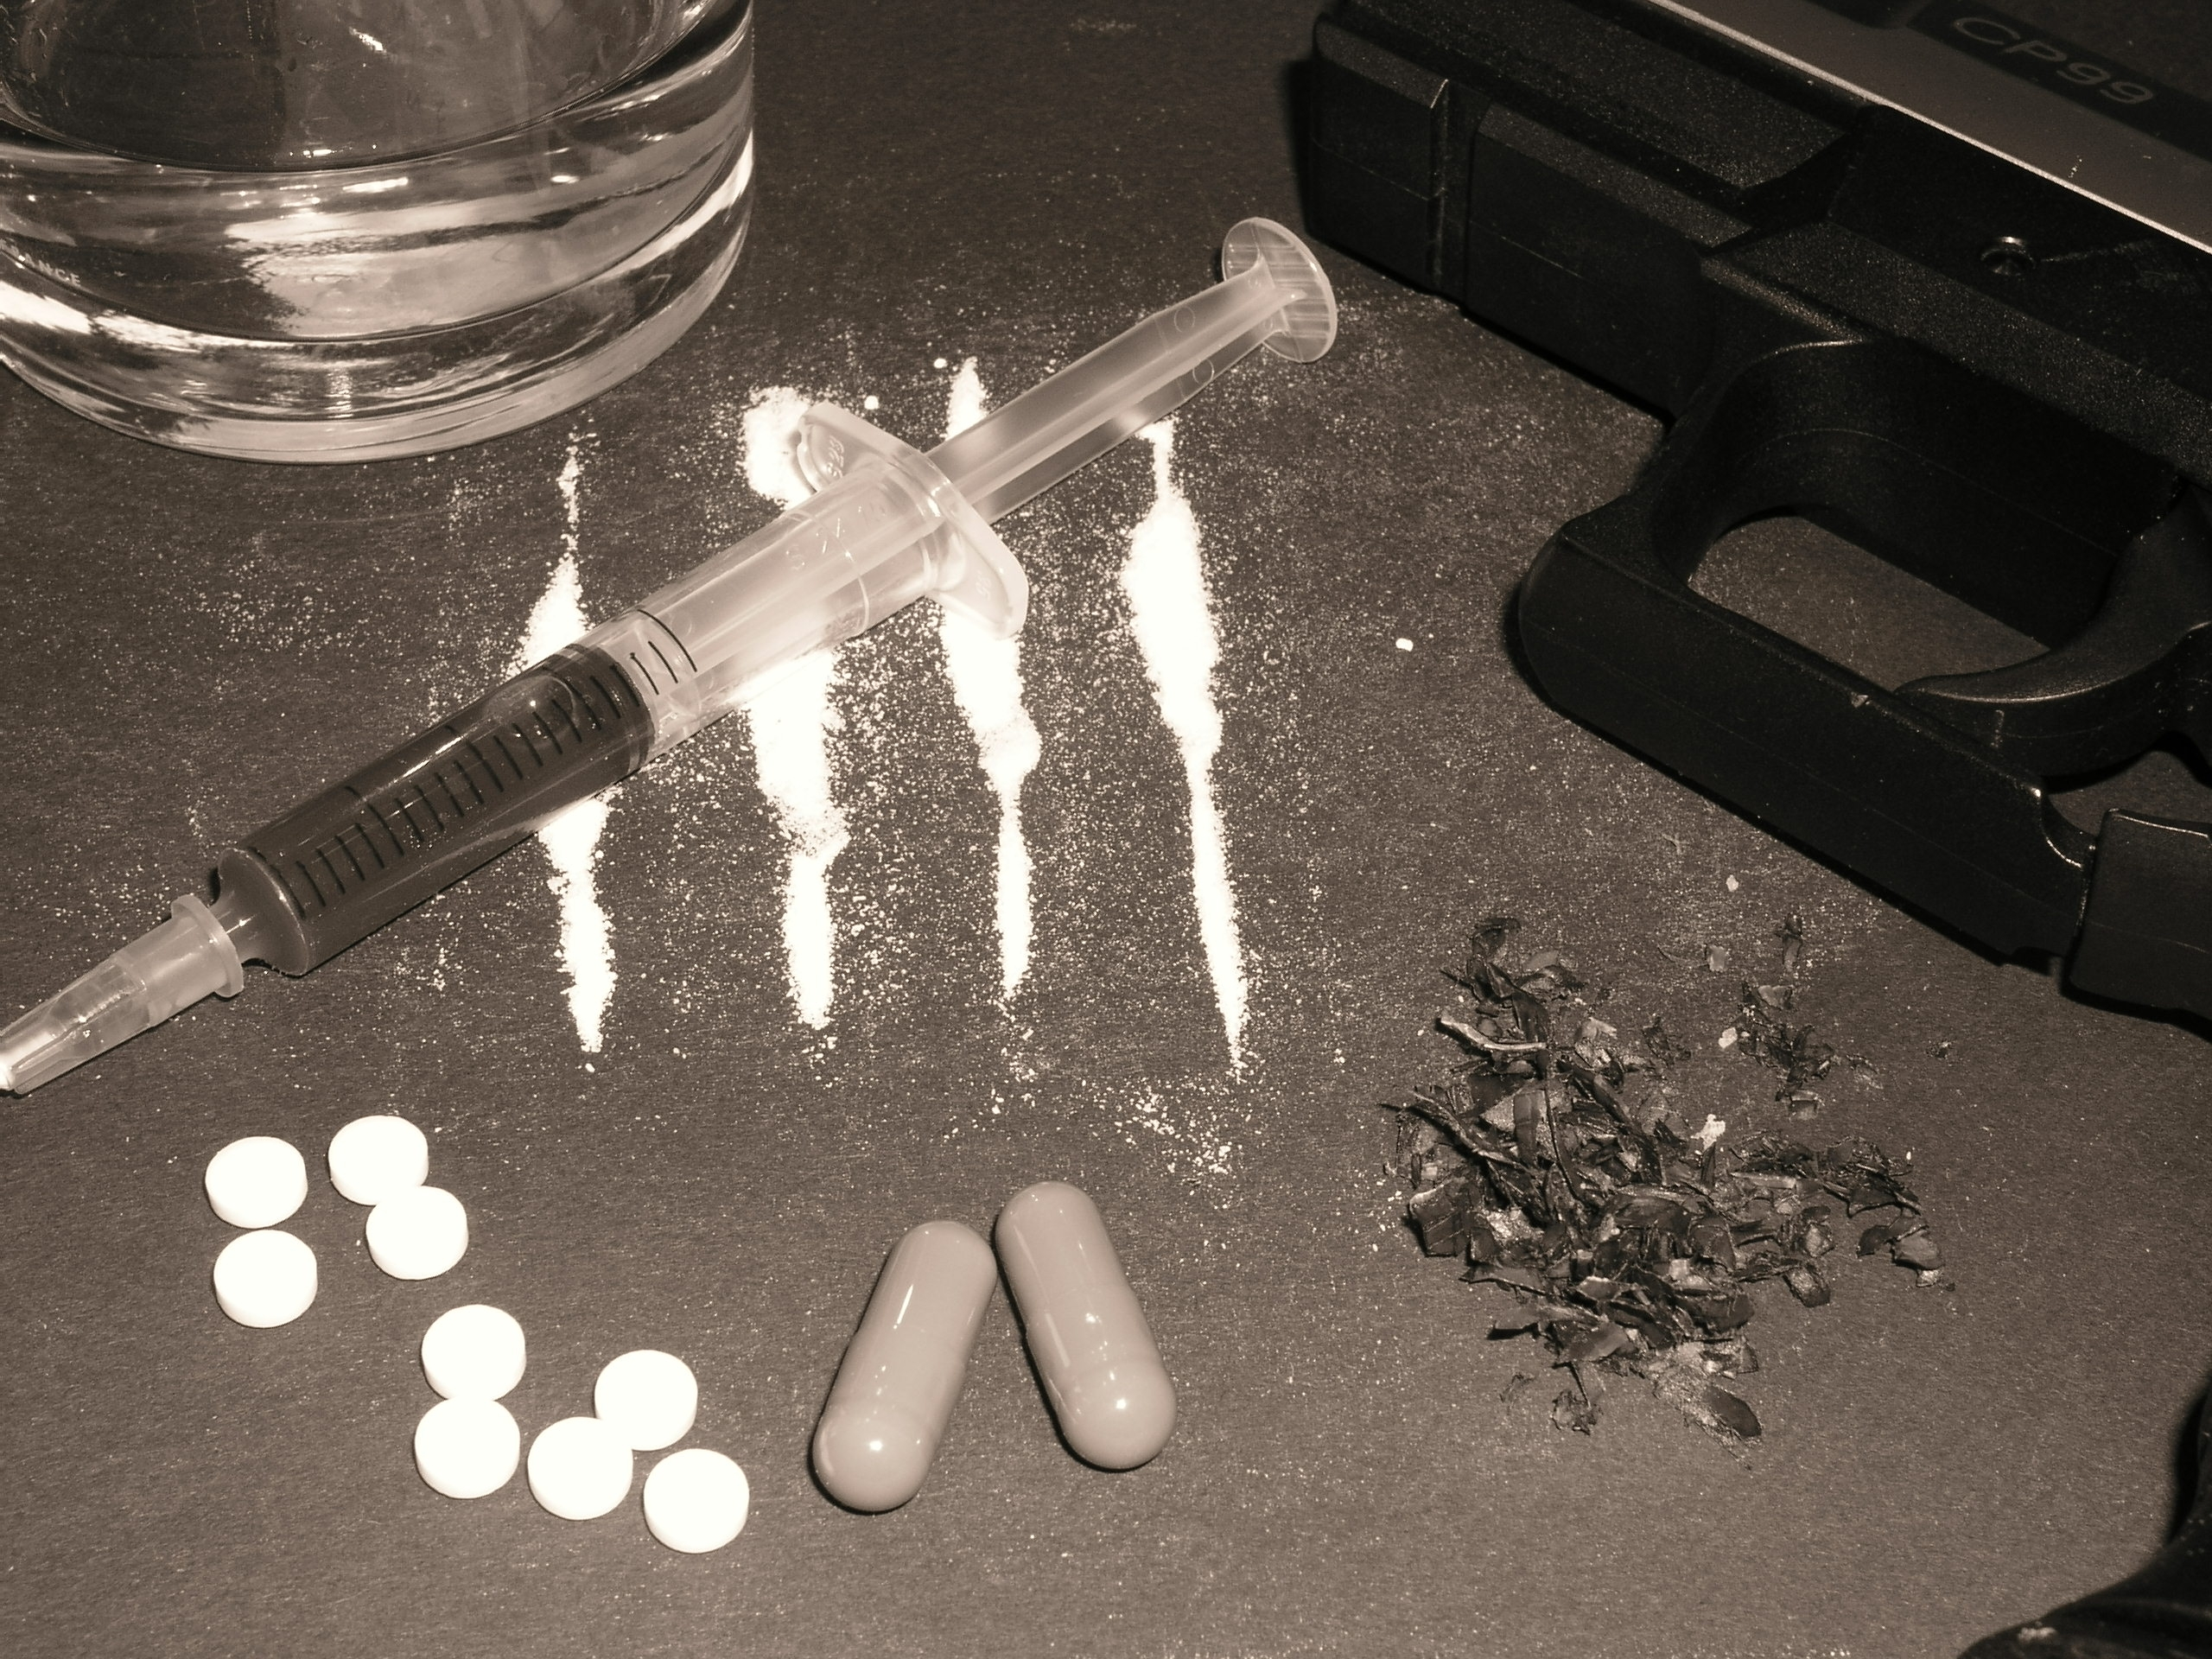
MIIA Professional Development Training

Date:
October 30, 2017

Time:
1:00pm-3:00pm

Presenter:
Steven Bernstein, LMHC

Location:
Bellingham Municipal Center
10 Mechanic St.
Bellingham, MA

Contact:
Beth Cornell-Smith
HR Director
508-966-2967
bsmith@bellinghamma.org

To Register:
Go to www.emiia.org and
click on “Training Calendar”

