1.800.451.1834
Presented by your Employee Assistance Program, offered through AllOne Health
DOT Drug and Alcohol Training for Managers
and Supervisors
The purpose of the DOT regulations is “to prevent, through deterrence and detection, alcohol and controlled substance users
from performing safety-sensitive functions.” Managers and supervisors must be keen observers and use constructive confrontation to deal with this volatile issue and comply with DOT regulations. Participants in this seminar will learn how to recognize signs of substance abuse as job and performance problems and DOT violations, constructively address these problems with employees, identify employee appearance and behaviors that trigger reasonable suspicion drug tests, and implement
the organization’s substance abuse policies.
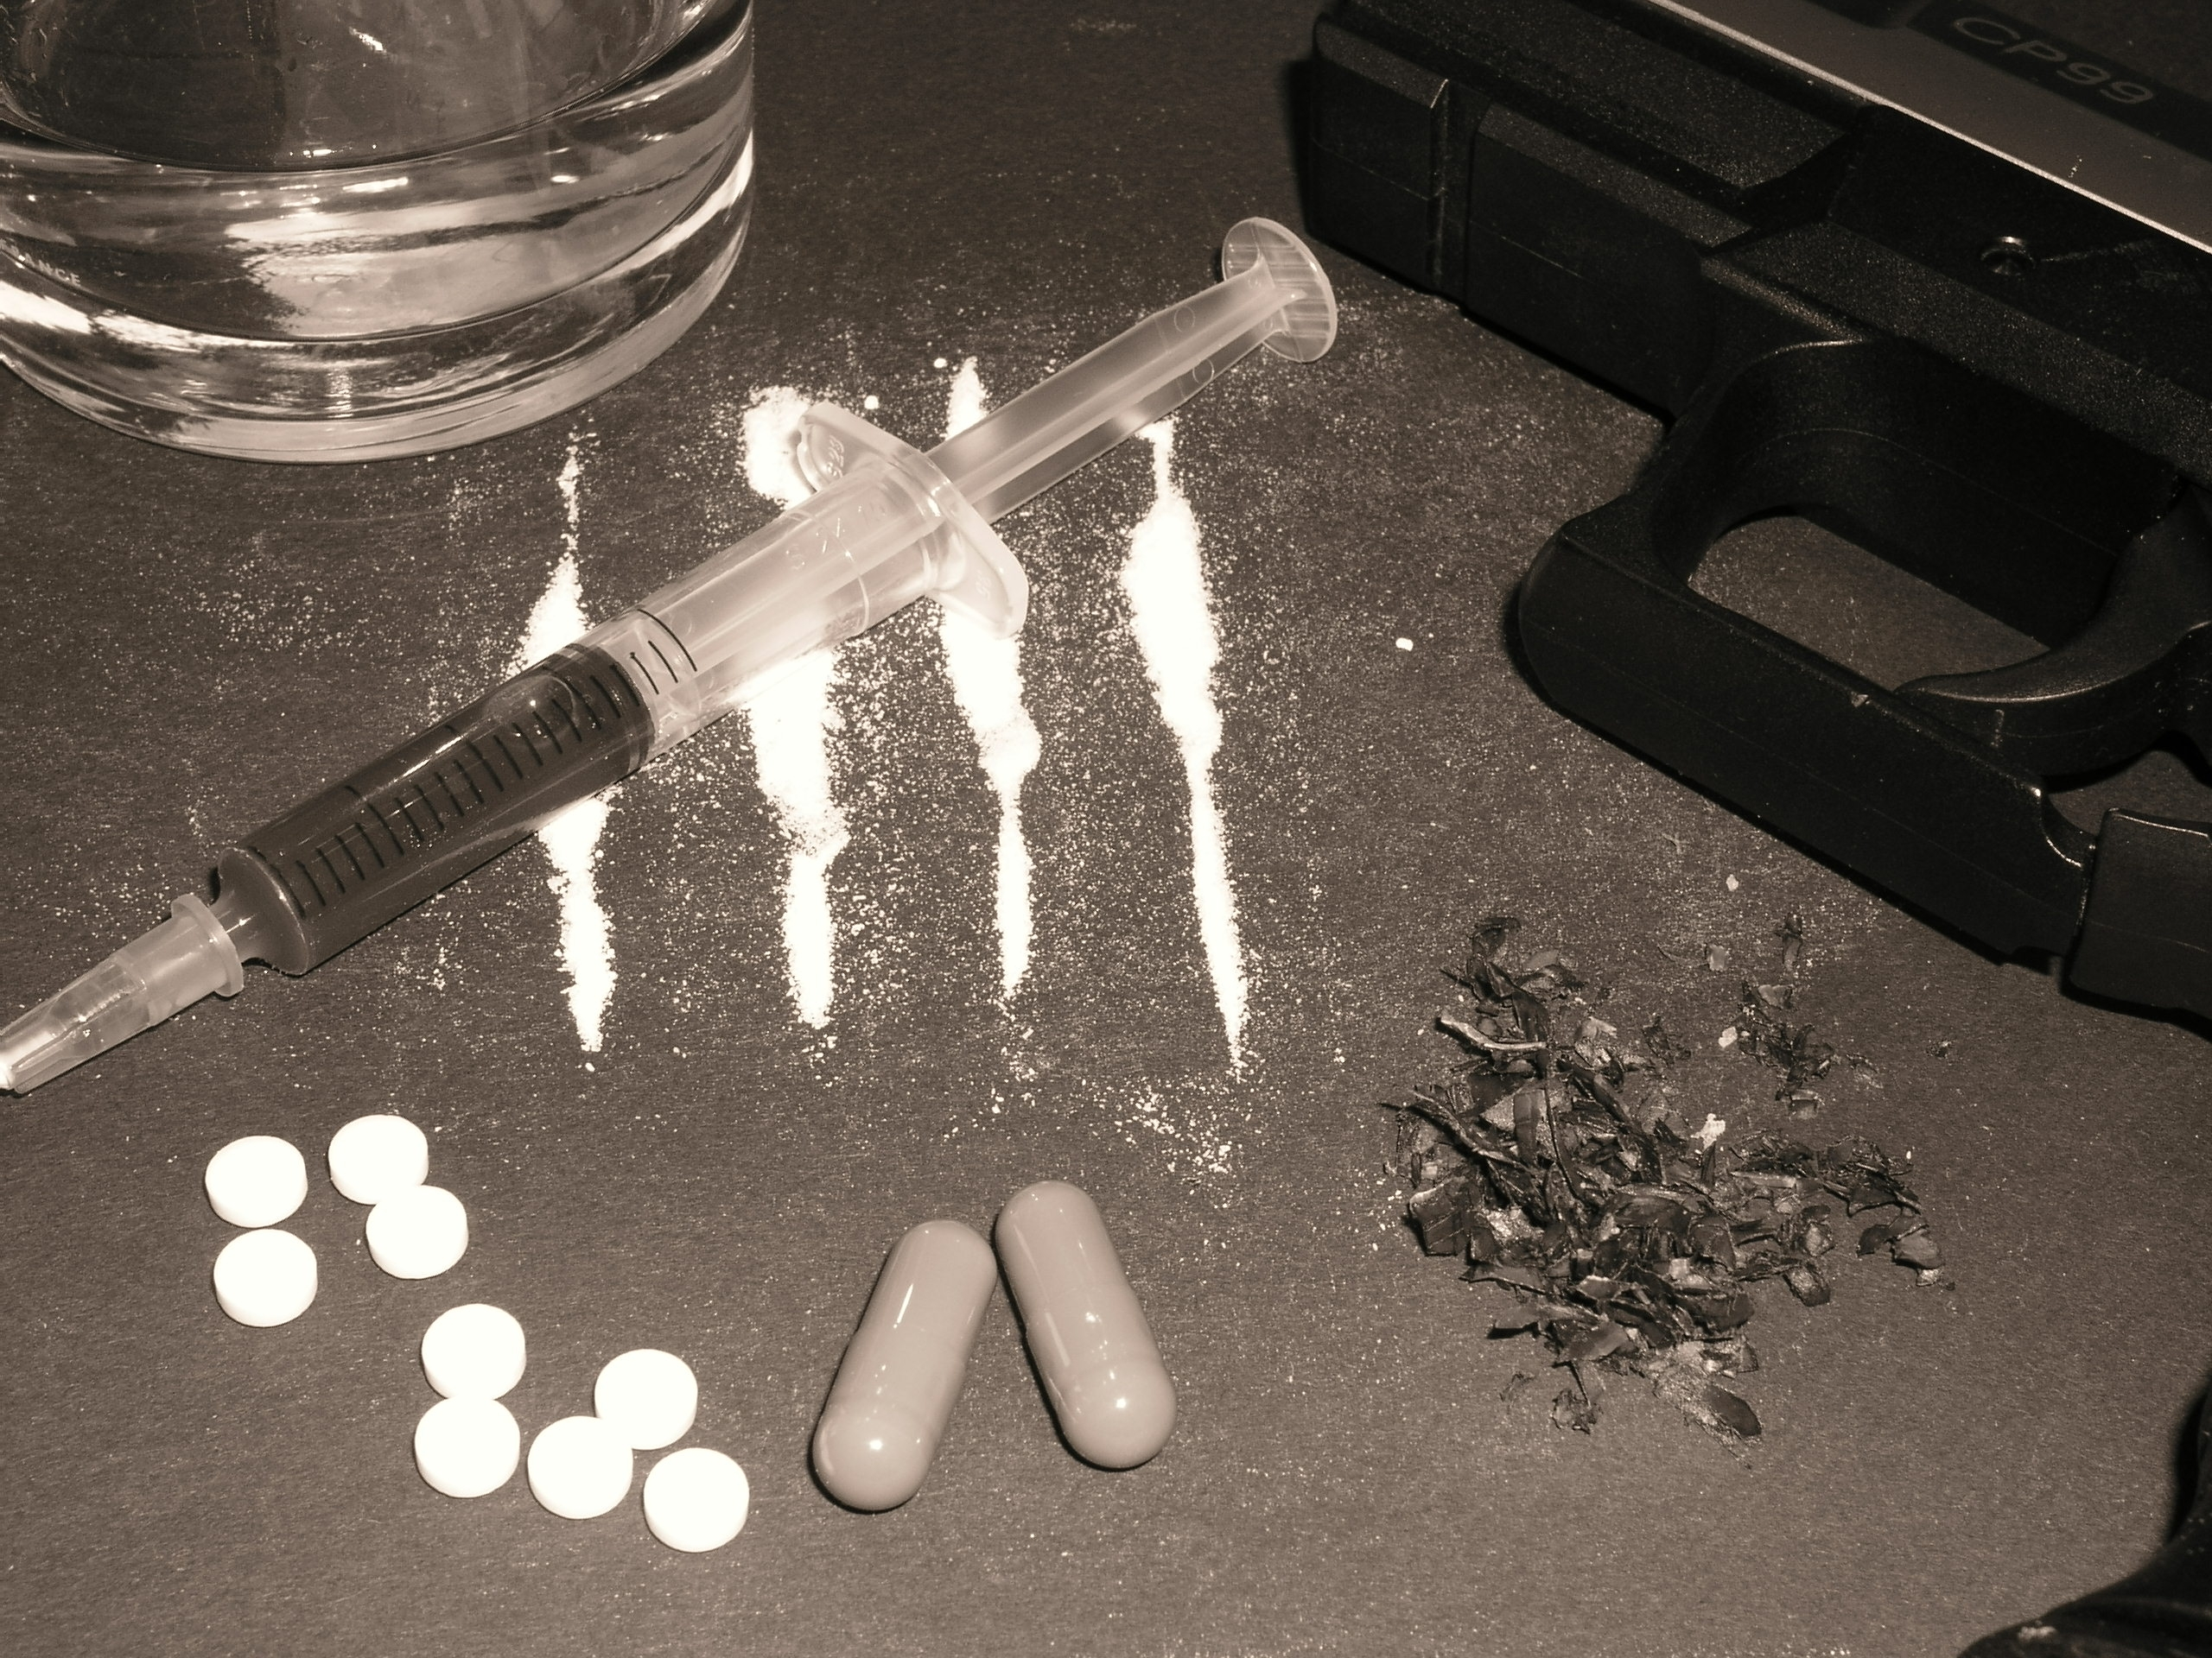
MIIA Professional Development Training

Date:
April 13, 2017

Time:
1:00pm-3:00pm

Presenter:
Bob Lenhardt

Location:
120 Washington Street
3rd floor
Salem, MA 01970

Contact:
Alicia Brady, Office Manager
abrady@salem.com
978-619-5630

To Register:
Go to www.emiia.org and
click on “Training Calendar”

