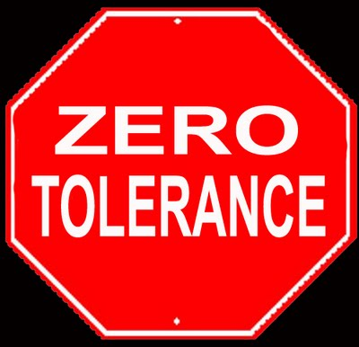
1.800.451.1834
Presented by your Employee Assistance Program, offered through AllOne Health

DOT Drug & Alcohol Awareness for Managers and Supervisors
The purpose of the DOT regulations is “to prevent, through deterrence and detection, alcohol and controlled substance users from performing safety- sensitive functions.” Managers and supervisors must be keen observers and use constructive confrontation to deal with this volatile issue and comply with DOT regulations. Participants in this seminar will learn how to recognize signs of substance abuse as job and performance problems and DOT violations, constructively address these problems with employees, identify employee appearance and behaviors that trigger reasonable suspicion drug tests, and implement he organization’s substance abuse policies.

MIIA Professional Development Training

Date:

Thursday, February 21st

Time:

2:00-3:00pm

Presenter:

Steven Bernstein, LMHC

Registration URL:

https://attendee.gotowebinar.com/register/3801433202922502913

