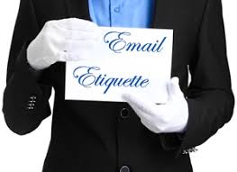
1.800.451.1834
Presented by your Employee Assistance Program, offered through AllOne Health

Email Etiquette
Most Americans view electronic communication as an essential part of professional and personal life. Research shows that the majority of us consider it a necessary work chore. Whether you are overwhelmed by the volume of electronic communication you receive, or perplexed/vexed by the culture of e-communication, this seminar is for you. This session will focus on the efficacy and etiquette of e-communications in order to improve the outcomes of e-exchanges.
MIIA Professional Development Training

Date:
June 7, 2018

Time:
1:00pm – 2:30pm

Presenter:
Allan Marsh, M. Ed.

Location:
Town Hall
1 Main Street
Ayer, MA 01432

Contact:
Kevin Johnston
kjohnston@ayer.ma.us

To Register:
Go to www.emiia.org and
click on “Training Calendar”

