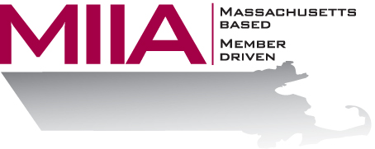
MIIA Professional Development Training

Energy Drainers: From Exhausted to Energized
Presenter: Cally Ritter, LICSW

June 16, 2016
2:00-3:00 PM

Today’s municipal workplace can be stressful, and there are always elements that seem to drain us even more: excel spreadsheets, difficult co-workers, longer hours.

In this webinar, we will look at techniques to revitalize ourselves on the job and find the motivation we need from within- to win
To register:
Please go to the following link and complete the required information:
https://attendee.gotowebinar.com/register/4245846984219793665
After registering, you will receive an email containing webinar access details. See you there!

