Excavations and Trenches – Competent Person Roles and Responsibilities
Presented by: Kimlee Lindgren, MIIA Senior Risk Management Trainer

Excavation cave-in and trench collapse pose the greatest risk to workers’ lives. The excavation competent person is a crucial component to protecting workers in and around excavations and trenches. This training will cover the applicable regulations and standards, as well the roles and responsibilities of the competent person with respect to safe excavation work.

DATE: Thursday, April 20, 2023
TIME: 8:00 a.m. to 3:00 p.m.
LOCATION: Easton Public Works, 130 Center Street, North Easton, MA 02356

TOPICS of DISCUSSION
- Roles and Responsibilities of the Competent Person
- Interaction with the Registered Professional Engineer (RPE)
- Applicable Standards and Regulations
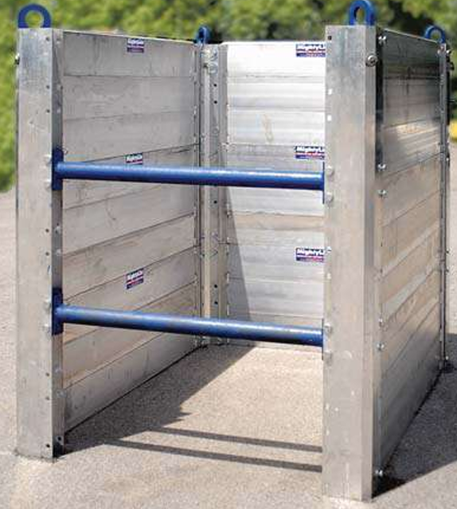
- Definitions and Terminology
- Excavation Hazards
- Soil Classification
- Protective Systems – Identification and Application
- Inspections and Corrective Actions
- Emergency Planning
- Case Studies
- Q and A

