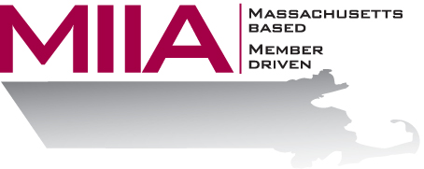
MIIA Professional Development Training

How Not to Take It Personally
June 14, 2018
2:00-3:00 PM

The world’s not out to get us. This is an important concept for life, but also for the world of work, where misunderstandings, miscommunication, and old ‘beefs’ often lead to hurt feelings and upset employees. In this webinar, we will develop tools to detach from situations, so we can de-personalize and find alternate ways of viewing situations, where we’re not the victim or hurt party. QTIP – Quit, Taking, It, Personally.

About the Presenters:
Steven Bernstein is an Account Manager at AllOne Health EAP, where he provides organizational support to varied client organizations. Steven has been in the mental health and employee assistance fields for over a decade, having worked in various clinical settings. Most recently, Steven has sought to combine his clinical and business interests through the EAP field. In his work, Steven looks to offer compassionate and effective solutions for various employee assistance challenges.

To register:
Please go to the following link and complete the required information:
https://attendee.gotowebinar.com/register/2600170561643624450
After registering, you will receive an email containing webinar access details. See you there!

