1.800.451.1834
From time to time, we all have to deal with people and situations that we find challenging; public service employees certainly face their fair share. While getting the job done efficiently and safely, the public service employee is expected to retain a positive public image for their department and municipality. When confronted with a resident’s disappointment, anger or entitlement, what one wants to say and what one should say are often two very different things. Participants in this seminar will learn specific techniques for defusing and resolving difficult situations with residents

Presented by your Employee Assistance Program, offered through AllOne Health
“I Pay Your Salary”:
Responding to Difficult Situations with Residents, Patrons and Customers

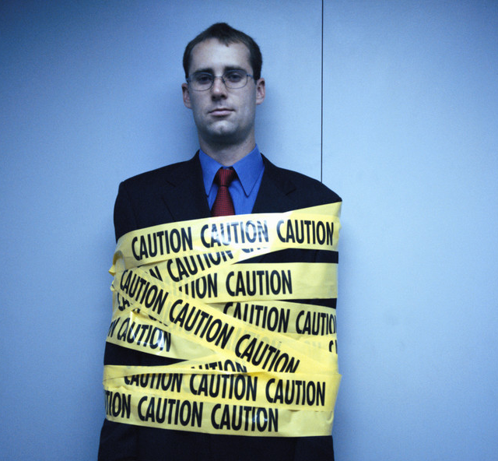
MIIA Professional Development Training

Date:
May 10, 2017

Time:
1:30pm-3:00pm

Presenter:
Cally Ritter

Location:
Town Hall
Selectman’s Room
1 Main St.
Ayer MA 01432

Contact:
Kevin A. Johnston
Benefits and Payroll Manager
978-772-8248
kjohnston@ayer.ma.us

To Register:
Go to www.emiia.org and
click on “Training Calendar”

