1.800.451.1834
From time to time, we all have to deal with people and situations that we find challenging; public service employees certainly face their fair share. While getting the job done efficiently and safely, the public service employee is expected to retain a positive public image for their department and municipality. When confronted with a resident’s disappointment, anger or entitlement, what one wants to say and what one should say are often two very different things. Participants in this seminar will learn specific techniques for defusing and resolving difficult situations with residents

Presented by your Employee Assistance Program, offered through AllOne Health
“I Pay Your Salary”:
Responding to Difficult Situations with Residents, Patrons and Customers

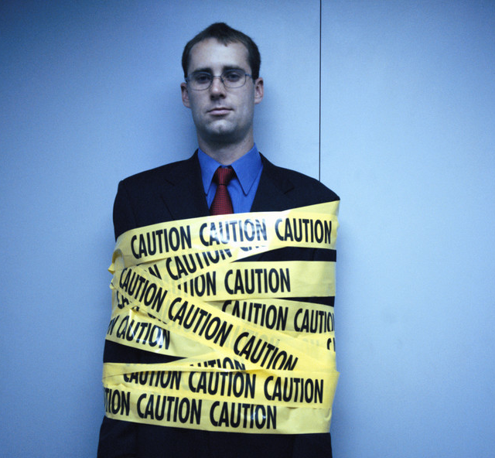
Date:
May 4, 2016

Time:
10:00am-11:30am

Presenter:
Cally Ritter

Location:
Grafton Police Station
28 Providence Road
Grafton, MA

Contact:
Joan Chase, HR Analyst
chasej@grafton-ma.gov
508-839-5335

To Register:
Go to www.emiia.org and
click on “Training Calendar”

MIIA Professional Development Training

