Ladder Safety Training
Presented by: Kimlee Lindgren, MIIA Senior Risk Management Trainer
There are more than 300 ladder-related deaths and over 130,000 emergency room visits related to ladders each year, as well as 2,000 ladder-related injuries every day.
In the workplace: the Bureau of Labor Statistics reported in 2020, 161 fatal work injuries from which ladders were the primary source. An additional 22,710 non-fatal ladder incidents resulted in a worker losing at least one day of work.

These statistics emphasize the need for ladder safety training.

DATE: Wednesday, April 5, 2023
TIME: 9:00 a.m. to 11:00 a.m.
LOCATION: Jericho Hill Recreation Area, 496 Brigham Street, Marlboro, MA 01752

DISCUSSION TOPICS and ACTIVITIES
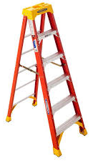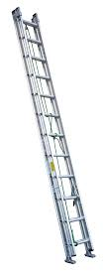
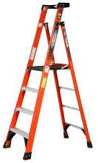
- Regulations and Standards
- Types of Ladders
- Duty Ratings
- Selection
- Inspection
- Use
- Storage
- Maintenance
- Disposal
- Q and A

