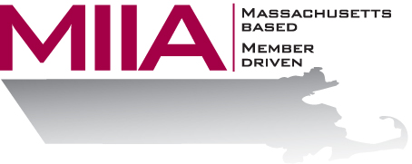
MIIA Professional Development Training

Leveraging Personality Differences on Our Teams
April 5, 2018
2:00-3:00 PM

People will always be different, and that’s a good thing! Diversity of thought can be an essential asset to your organization. The trick is learning how to best leverage employees’ personality differences. In this webinar, we will look at certain personality types (such as introverts and extroverts), consider where each tends to shine, and learn how to align them with their natural tendencies. Understanding ourselves, and others, allows for enhanced cohesion, motivation, creativity, and morale in the workplace.

About the Presenter:
Steven Bernstein is an Account Manager at AllOne Health EAP. There he provides organizational support to varied client organizations. Steven has been in the mental health and employee assistance fields for over a decade, combining his business and clinical interests. In his work, Steven looks to offer compassionate and effective solutions for various employee assistance challenges. Steven also maintains a small psychotherapy practice, specializing in couples’s work. In his downtime, Steven likes a good movie, joke, and/or meal. His newest passion is his puppy, Dallas.

To register:
Please go to the following link and complete the required information:
https://attendee.gotowebinar.com/register/5205699758658129409
After registering, you will receive an email containing webinar access details. See you there!

