MIIA
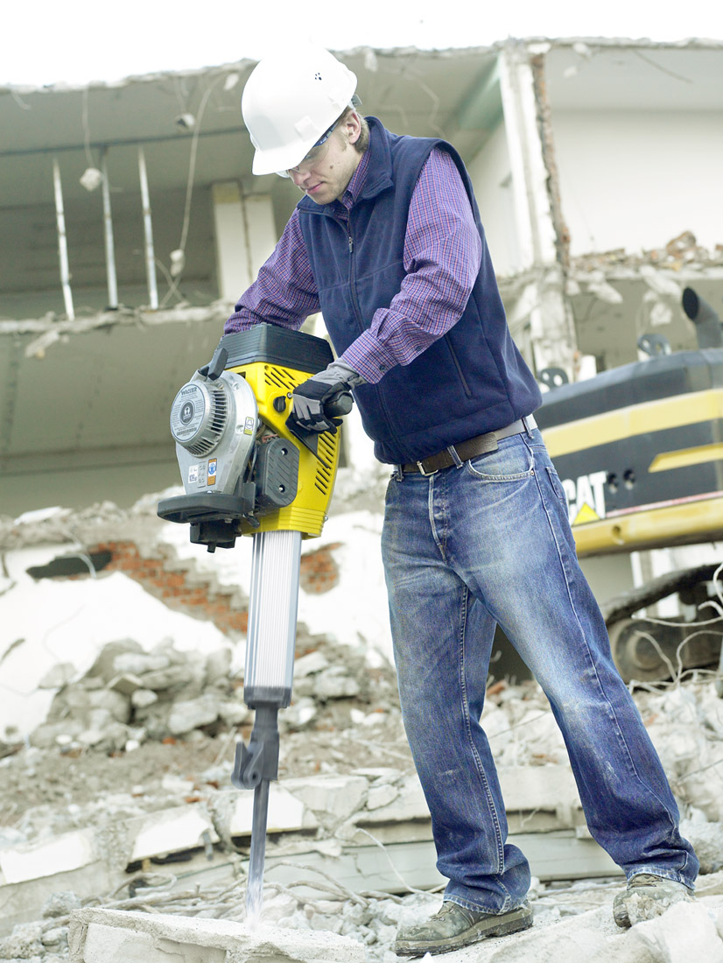
Back Injury Prevention (BIP) Zoom Presentation

DATE: Thursday, June 25, 2020

TIME: 12:00pm – 12: 45 pm

LOCATION: Your Home or Work Office

The Purpose of this MIIA Back Injury Prevention training is to:

Prevent a costly muscle strain, sprain or fracture like a painful back injury from occurring through good preventative common sense measures.

PROGRAM OUTLINE

- ZOOM PRESENTATION: (40 minutes)

Discuss and teach “best practice” material handling skills and lifting techniques. This class is primarily designed for public works personnel, school custodians and facility/maintenance workers. The ultimate goal is to avoid injury caused by one bad lift or physical trauma caused by repetitive motion or misuse of the back. Spinal injuries can be devastating so the instructor will motivate those individuals with a history of back pain, or other orthopedic injury issues to use helpful postures, lifting techniques, body mechanics and pre-work stretching exercises to decrease the likely hood of a first-time injury, or a recurrence.

- CONCEPTS IN LIFTING: ( 10- Minutes)

During the second part, the instructor will video tape proper material handling techniques and proper at work lifting techniques and skills.

3. POST CLASS EVALUATION AND STRETCHING DEMO 10-MINUTES

The third part of the session involves demonstrating warm-up routines that can be done at work. These routines are designed to; increase safe work practices, improve circulation, improve back flexibility and strength.

