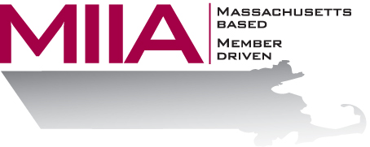
MIIA Professional Development Training

Effective Hiring: For DPWs
Presenter: Steven Bernstein, LMHC, CEAP

May 12, 2016
2:00-3:00 PM

Finding talented employees is always a challenge, but it can be especially difficult for DPWs, because there is no formal training academy. This webinar looks at this challenge, and at some of the tools and strategies that can be utilized to retain employees and hire to tenure.

To register:
Please go to the following link and complete the required information:
https://attendee.gotowebinar.com/register/3635736778257584129

After registering, you will receive an email containing webinar access details. See you there!

