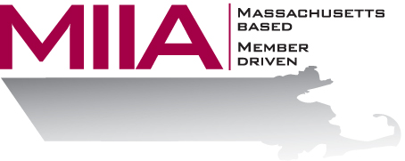
MIIA Professional Development Training

Navigating Social Media
Presenter: Adam Mintz, LMHC

April 26, 2016
2:00-3:00 PM

Today’s social media landscape is a complicated one. And municipalities often have questions about how to effectively use it.

This webinar will look at the strategic, legal, and organization challenges of effectively using social media today.

To register:
Please go to the following link and complete the required information:
https://attendee.gotowebinar.com/register/9136733089799899393
After registering, you will receive an email containing webinar access details. See you there!

