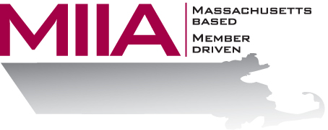
MIIA Professional Development Training

The New Science of Stress
April 6, 2017
2:00-3:00 PM

You can’t open a newspaper, magazine or website without seeing messages that stress is bad for our health. Stress is accused of causing heart disease, cancer, and even Alzheimer’s. But what if that is not the case? What if stress makes you smarter, stronger, happier and more resilient? What if stress is just like a muscle, and the more you use it, the better is becomes? The latest science finds that it is not the stressor we experience that makes us sick, but our stress mindset. Rather than trying to reduce, avoid or escape our stress, understanding and embracing it may be the secret to resilience and longevity. Attend this webinar to learn about the latest science and strategies
regarding stress.

About the Presenter:
Cally Ritter is an EAP consultant with AllOne Health EAP, and a Licensed Independent Clinical Social Worker. She has a B.A. from Bucknell University, a master of social work from the University of Pittsburgh, and twenty years of clinical experience in a variety of settings, including inpatient and outpatient services in Philadelphia, Pittsburgh and Boston. Cally has been an EAP trainer for more than ten years, and has presented on a variety of personal and professional development topics. Her areas of interest include the multigenerational workplace, resiliency and employee motivation. She infuses her seminars with energy, examples, exercises, and content excellence.

To register:
Please go to the following link and complete the required information:
https://attendee.gotowebinar.com/register/8541364043484687107
After registering, you will receive an email containing webinar access details. See you there!

