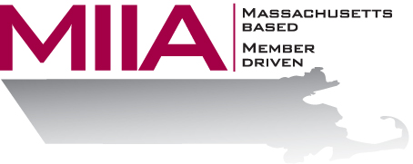
MIIA Professional Development Training

The Opioid Epidemic and Your Municipality
December 6, 2016
2:00-3:00 PM

All you have to do is pick up the paper today to see news about the opiate epidemic - and it’s rarely good. How do we understand this substance abuse phenomenon? How is it playing out within the Commonwealth, and what are its specific effects within your municipality? How are individual departments, like Public Safety, managing or combating the problem? In this webinar, we’ll be addressing the opioid epidemic in a general sense, as well as looking at signs and symptoms of substance use, important addiction concepts, and various support resources.

About the Presenters:
Steven Bernstein is an Account Manager at AllOne Health EAP, where he provides organizational support to varied client organizations. Steven has been in the mental health and employee assistance fields for over a decade, having worked in various clinical settings. Most recently, Steven has sought to combine his clinical and business interests through the EAP field. In his work, Steven looks to offer compassionate and effective solutions for various employee assistance challenges.

Robert Lenhardt, LICSW, is in his 23rd year with AllOne Health EAP, specializing in on-site workplace crisis response and substance abuse issues at work and at home. He oversees EAP services that are provided to organizations following a trauma or critical incident. He trained with police psychologist Dr. Jeffrey Mitchell in 1990, and has conducted numerous grief groups and trauma debriefings in a wide variety of work settings, including emergency services personnel. He has been conducting workplace training on this topic for more than 10 years.

Dan O'Connor has been involved in the field of Addiction Recovery since 1993. He started a Members Assistance Program in a Labor Union, which he coordinated from 1993 to 2015, and has been a Certified Employee Assistance Professional since 1998. He is the Past President of the Employee Assistance Professional Association, and its past International Labor Director. Dan is also the past President of Labor Assistance Professionals of Massachusetts. He received a Master’s degree in Counseling Psychology with a concentration in Addictions from Cambridge College in 2010, and has been a Licensed Alcohol and Drug Counselor Level 1 in Massachusetts since 2008. In 2015, Dan started working for AdCare Hospital as a community Services representative. He is currently on the Executive Board of the Massachusetts Organization on Addiction Recovery, and is the legislative Director for Labor Assistance Professional in Massachusetts.

To register:
Please go to the following link and complete the required information:
https://attendee.gotowebinar.com/register/2546343963244181249
After registering, you will receive an email containing webinar access details. See you there!

