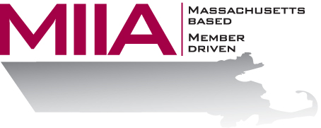
MIIA Professional Development Training

The Police and Your Community
February 6, 2017
2:00-3:00 PM

It’s no secret that being a police officer is stressful work. This is doubly true today, when law enforcement is up against a myriad of issues and tensions – an increasingly unpredictable world, racial tensions, and the like. How do our bravest men and women take care of themselves amidst these pressures? How are individual municipalities navigating challenges around diversity? What kinds of ideas, resources, and supports are available to help communities and Public Safety with these complex questions?

About the Presenter:
Chief John J. Moore has spent his 29-year career in the criminal justice field; first, as a criminal defense attorney (1988-1995), then as a police officer (1995-present). He’s been the Chief of Police for Holliston since February of 2011 and is a member of the Massachusetts Chiefs of Police Association, the Middlesex County Chiefs of Police Association, the New England Chiefs of Police Association, the International Association of Chiefs of Police Association, and the FBI Law Enforcement Executive Development Association.

To register:
Please go to the following link and complete the required information:
https://attendee.gotowebinar.com/register/8439859329031479299
After registering, you will receive an email containing webinar access details. See you there!

