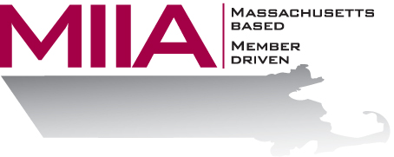
MIIA Professional Development Training

Best Practices in Progressive Discipline
February 8, 2018
2:00-3:00 PM

Determining the most effective path for employee discipline can be tricky, given the variety of factors that confront today’s HR professional – policy considerations, unions, the unpredictability of an employee’s response, and other variables. In this webinar, we will look at best practices with respect to employee discipline, and consider examples of situations that have worked or not worked, all with an eye towards crafting effective disciplinary plans for both employers and employees.

About the Presenters:
Steven Bernstein is an Account Manager at AllOne Health EAP, where he provides organizational support to varied client organizations. Steven has been in the mental health and employee assistance fields for over a decade, having worked in various clinical settings. Most recently, Steven has sought to combine his clinical and business interests through the EAP field. In his work, Steven looks to offer compassionate and effective solutions for various employee assistance challenges.

Panel members:
Judi Perkins, HR Director, Town of Reading
Jeannie Horne, HR Director, Town of Duxbury
Candace Hall-Nourse, HR Director, Town of Andover

To register:
Please go to the following link and complete the required information:
https://attendee.gotowebinar.com/register/6775138258097710595
After registering, you will receive an email containing webinar access details.
See you there!

