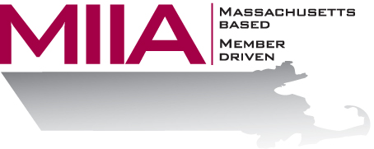
MIIA Professional Development Training

Reasonable Suspicion and DOT Regulations
November 17, 2016
2:00-3:00 PM

Managers and supervisors sometimes have a hunch that an employee may be under the influence of drugs or alcohol – but they’re not sure. What does one do under these unclear circumstances? This webinar will explore the concept of Reasonable Suspicion, the term used when assessing for possible drug/alcohol use in the workplace. What are the signs and symptoms to be on the lookout for; what is your role as a manager; what are the different types of tests available; and how does one best intervene or make a referral? Depending on your department, we’ll also look at important Department of Transportation (DOT) considerations and regulations, as well as your own internal Alcohol & Drug Policy.

About the Presenter:
Steven Bernstein is an Account Manager at AllOne Health EAP. There he provides organizational support to varied client organizations. Steven has been in the mental health and employee assistance fields for over a decade, having worked in various clinical settings. Most recently, Steven has sought to combine his clinical and business interests through the EAP field. In his work, Steven looks to offer compassionate and effective solutions for various employee assistance challenges.

To register:
Please go to the following link and complete the required information:
https://attendee.gotowebinar.com/register/623059532240386305
After registering, you will receive an email containing webinar access details. See you there!

