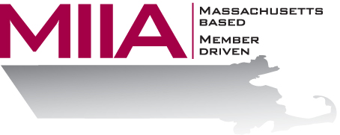
Workers Compensation : Return to Work

Best Practices

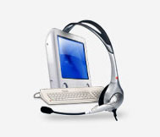
June 11, 2019
10:00 am - 11:00 am

June 11, 2019

10:00 a.m.-11:00 a.m.

MIIA is excited to sponsor this webinar which will focus on stay-at-work/return-to-work workers’ compensation best practices. Employers experience lower cost, reduced lost time and eliminate possibilities for fraud and malingering by providing opportunities for their injured workers to continue to do productive work while they are recovering. Because injured workers who stay at work or who are returned to productive work, as soon as possible following an injury, require less medical care and experience less disability, workers' compensation medical costs are significantly reduced. Further, indirect costs are mitigated as well.

This webinar is designed to assist MIIA members in developing their own return to work procedures. Learn about the benefits and purpose of early return to work and how to implement a successful process. The webinar will be led by Niko Pappas (MIIA Director of WC Claims) and Dr. Jennifer Christian (MIIA Medical Director). To register:
Please go to the following link and complete the required information:
https://attendee.gotowebinar.com/register/7736885491797575426

