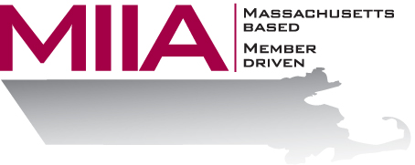
MIIA Professional Development Training

Attracting the Next Generation
September 5, 2017
2:00-3:00 PM

While millennials are today’s fastest growing generation, organizations are often not doing enough to attract younger employees. Why is this, and what can be done to remedy it? In this webinar, we will explore the obstacles to hiring younger folks, look at way of attracting them into today’s municipal workplace, and find ways of leveraging their particular skill set for the benefit of the municipal environment.

About the Presenter:
Kimberly Jones, LCSW is a military veteran who recently joined AllOne Health. As a Licensed Certified Social Worker, her experience includes providing therapeutic support to couples, families, and children, serving adults with co-occurring disorders in addiction treatment, and crisis management. Her areas of expertise include, but are not limited to: adjustment disorders, anxiety disorders, ADHD/ADD, behavior modification, and cognitive behavioral therapy. Kimberly earned a master’s degree in Social Work from New York University, NY. She enjoys traveling and meeting new people.

To register:
Please go to the following link and complete the required information:
https://attendee.gotowebinar.com/register/3788861378503803394
After registering, you will receive an email containing webinar access details. See you there!

