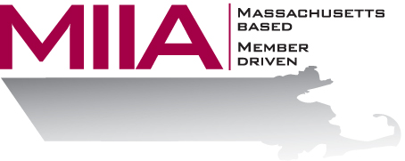

Sleep On It: The Importance of
Getting a Good Night’s Sleep
October 15, 2015
1:00-2:00 PM

It’s no secret that Americans in general are sleep deprived. Shift workers in particular are often excessively drowsy. This webinar addresses the sleeplessness epidemic and provides information for municipal employees, including winter snowplowers. Common myths and facts about sleep will be discussed, as well as common sleep disorders. Emphasis will be on strategies and tips for getting adequate sleep in the face of extreme scheduling demands.

About the Presenter:
Dr. Fred Kohanna is the Corporate Medical Director for AllOne Health, based in Woburn, Massachusetts. He is board certified in both emergency medicine and occupational and environmental medicine. Dr. Kohanna develops innovative, customized occupational and environmental health services solutions for a range of clients. His expertise includes environmental exposures, medical surveillance programs, drug and alcohol testing, work-related injury management, wellness and health promotion, travel medicine, and pre-placement health screening. Dr. Kohanna received his undergraduate degree from Columbia University and his medical degree from George Washington University. He has an MBA from Northeastern University. He is a Fellow in the American College of Occupational and Environmental Medicine, and is a certified Medical Review Officer.

To register:
Please go to the following link and complete the required information: https://attendee.gotowebinar.com/register/271802941294125570
After registering, you will receive an email containing webinar access details. See you there!

