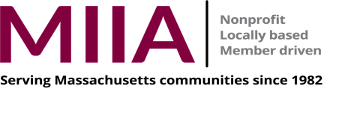
This is a 5- part series. MIIA Rewards credit will only be awarded for participation in the entire series.
Registration for session one will automatically register you for all 5 sessions. These sessions are very interactive so we ask that you remain on camera throughout each session.
“Special Topics in Supervisory Skills” Program for DPW Foremen/Supervisors
Session one- April 20, 2021, Session 2, April 27, 2021, Session 3, May 4, 2021
Session 4, May 11, 2021, Session 5, May 18, 2021
All sessions: 1:00 p.m. – 2:30 p.m.
Whether you are a first-time supervisor or foreman, or preparing yourself for a promotion later in your career, this five-session training program will help you sharpen your leadership skills and bolster your confidence as you go forward with your current and future responsibilities.

The series consists of the following topics:

Session 1: Transitioning to a Supervisory Position

- Transitioning to foreman or supervisor
- Stages of skill development
- Supervising former co-workers
- Developing self-confidence

Session 2: Establishing Roles and Responsibilities

- Clarifying roles, responsibilities and expectations
- Decision-making styles
- Establishing credibility and trust

Session 3: Supervisory Communication Skills

- Effective listening skills
- Communicating up, down and across your department
- Good news, bad news and persuasive communication
- Leadership communication

Session 4: Dealing with Challenging Employees

- Following a problem-solving method
- Dealing with challenging employees
- Having difficult conversations

Session 5: Building Individual Development Plans

- Setting a self-development goal
- Developing a personal action plan

Presenter
Rockie Blunt, EdD, BCG’s president, has built a reputation as a dynamic presenter and skillful facilitator. The cornerstone of his approach is establishing a comfortable, supportive atmosphere in which his clients develop self-confidence and enhance their capacity to learn. Rockie's approach is summed up this way: "I don't teach people. I help them learn."
He has a bachelor's degree from Yale University, a master's from Clark University, and a doctorate in Human Resource Education from Boston University.

