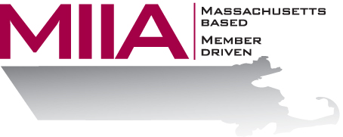
MIIA Professional Development Training

Recognizing the Signs of the Troubled Employee
March 16, 2017
2:00-3:00 PM

Mental health issues are increasingly affecting America’s workforce. Statistics indicate that millions of people struggle with the symptoms of anxiety, depression, and substance abuse. These symptoms, whether treated or
untreated, often enter the work environment, sometimes requiring managers to intervene. Managers often feel ill prepared and anxious when dealing with the troubled employee. This seminar will help build the manager’s competence and confidence when faced with a troubled employee. Additionally, managers will leave the seminar with a clear understanding of when and how to intervene.

About the Presenter:
Cally Ritter is an EAP consultant with AllOne Health EAP, and a Licensed Independent Clinical Social Worker. She has a B.A. from Bucknell University, a master of social work from the University of Pittsburgh, and twenty years of clinical experience in a variety of settings, including inpatient and outpatient services in Philadelphia, Pittsburgh and Boston. Cally has been an EAP trainer for more than ten years, and has presented on a variety of personal and professional development topics. Her areas of interest include the multigenerational workplace, resiliency and employee motivation. She infuses her seminars with energy, examples, exercises, and content excellence.

To register:
Please go to the following link and complete the required information:
https://attendee.gotowebinar.com/register/8154868114135261443
After registering, you will receive an email containing webinar access details. See you there!

