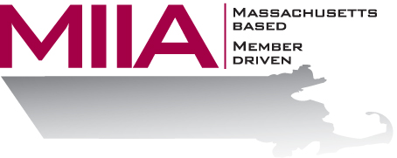
MIIA Professional Development Training

Recognizing the Signs of the Troubled Student
January 18, 2017
2:00-3:00 PM

We all know that children sometimes have a hard time in school. But when does a child’s normal developmental challenges cross the line to a significant behavioral or emotional problem? This is an especially relevant question when we consider the various issues faced by schools today. In this webinar, we will be looking at the signs and symptoms of a troubled student, the impact of substance abuse on today’s youth, how to talk to kids about your concerns, and various resources to assist with turning around or positively impacting a child.

About the Presenter:
Joseph Yarid, LICSW, is the School Social Work Coordinator for Andover Public Schools. Prior to working in Andover, Mr. Yarid worked as a public
sector Social Worker with the MA Department of Mental Health Child/Adolescent Services, and then as a School Social Worker at Merrimack Special Education Collaborative, working with non-traditional students at both Middle and High School levels. In Andover, he continues providing Social Work support at the Middle School level while also supervising the district's School Social Workers, who dedicate their time serving a wide variety of students, families, staff, and the larger community through varying degrees of school-based social work assistance.

To register:
Please go to the following link and complete the required information:
https://attendee.gotowebinar.com/register/3272774803041454596
After registering, you will receive an email containing webinar access details. See you there!

