1.800.451.1834
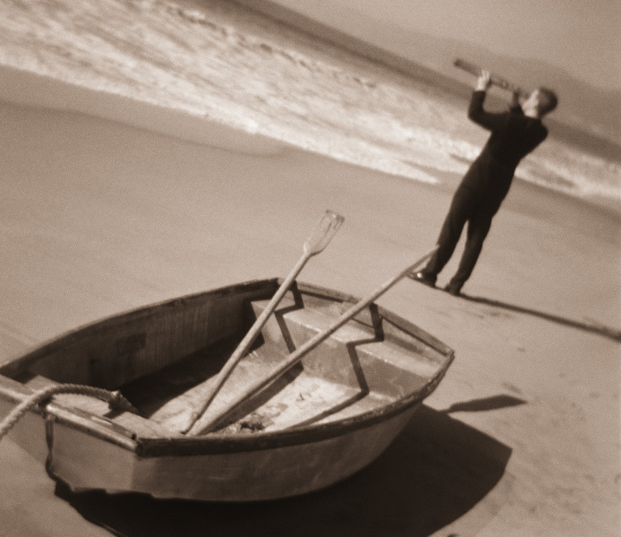
Riding the Waves of Workplace Uncertainty and Change
In today’s fast-paced municipal environment, employees face frequent and often unpredictable change of varying scope. These changes produce stress at work and at home.

This workshop will explain normal reactions to change and uncertainty at work, highlight factors that create stress, and explain techniques to decrease the negative impact of stress.

Presented by your Employee Assistance Program, offered through AllOne Health
MIIA Professional Development Training

Date:
June 15, 2016

Time:
10:00am-11:30am

Presenter:
Cally Ritter

Location:
Grafton Police Station
28 Providence Road
Grafton, MA

Contact:
Joan Chase, HR Analyst
chasej@grafton-ma.gov
508-839-5335

To Register:
Go to www.emiia.org and
click on “Training Calendar”

