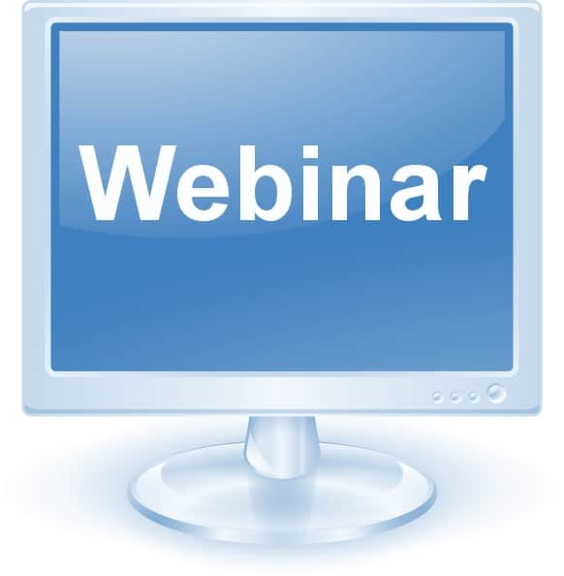
This Photo by Unknown Author is licensed under CC BY
Join Us for a Webinar:

MIIA Presents "What to do if there is a Data Incident"
Wed, Oct 23, 2019 2:00 PM - 3:00 PM EDT
Join MIIA and Greg Bautista from Wilson Elser as we review what you would need to do if you experience a data incident. Greg Bautista is a partner and co-chair of the Cybersecurity and Data Privacy practice at the law firm Wilson Elser. As a MIIA policyholder, you also have access to MIIA CyberNET® Protection which includes access to expert cyber risk advisors when you need them, plus 24/7 online training courses, sample cyber risk policies and procedures, as well as guidance with sample contract provisions that can be added to vendor agreements to reduce cyber risk exposure.
Register below
https://register.gotowebinar.com/register/5668513906943635469

