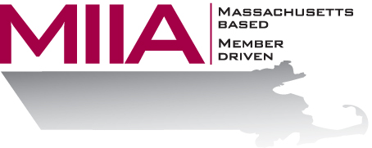
MIIA Professional Development Training

What Do I Say: Responding to Colleagues After Loss
January 4, 2018
2:00-3:00 PM

When something tragic has happened or there’s been a death, we may find ourselves at a loss for words, uncertain how to proceed. This is particularly difficult in the workplace, as boundaries in workplace relationships are often unclear. Attend this webinar to learn how to avoid making insensitive comments, and how best to support your team members after a loss. This webinar will explore critical incidents, critical incidents stress response, the grief process, common missteps, and supportive actions colleagues and managers can take.

About the Presenter:
Cally Ritter is the Director of Training and Development for AllOne Health EAP, and a Licensed Independent Clinical Social Worker. She has a B.A. from Bucknell University, a master of social work from the University of Pittsburgh, and over 25 years of clinical experience in a variety of settings, including inpatient and outpatient services in Philadelphia, Pittsburgh and Boston. Cally has been an EAP trainer for more than 20 years, and has inspired countless audiences to make shifts in their thinking and behavior for greater work/life effectiveness. Cally presents at national, regional, and state conferences, and facilitates retreats. Additionally, she is a certified Motivation Factor facilitator. Her areas of interest include the multigenerational workplace, stress/resiliency and employee motivation. She infuses her seminars with energy, examples, exercises, and content excellence. Cally feels fortunate to engage daily with audiences and be present for personal and professional transformation.

To register:
Please go to the following link and complete the required information:
https://attendee.gotowebinar.com/register/6799453957745698819
After registering, you will receive an email containing webinar access details. See you there!

