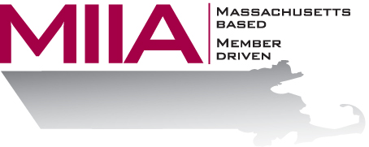
MIIA Professional Development Training

Working Effectively With Elected Officials,
Appointed Boards and Committees
January 28, 2016
2:00-3:00 PM

The roles between town department heads and elected officials or board members vary widely. What are keys to successful collaboration? Hear from the Town of Holliston as Will Brown moderates a panel discussion with former Town Administrator of 32 years, Paul LeBeau, current Select Board Chair Jay Marsden and Mary Greendale, Town activist and former Board member. Topics covered include:
- Best practices to manage communication between staff and board members both within and outside of public meetings.
- Appreciating and respecting the multiple municipal roles that govern a fair and impartial process.
- The importance of preparation and advance communication in reducing misunderstandings and achieving desired outcomes.
Bring questions for the panel and learn strategies that you can take back to your town.

About the Presenter:
Will Brown is the Manager of Municipalities and Organization Development at AllOne Health. Will holds Masters degrees in Social Work and Education, is a Licensed Independent Clinical Social Worker, and a Certified Employee Assistance Professional. Will is founder of TeamWorks Institute, a consulting resource dedicated to helping organizations resolve workplace conflict through mediation and team building. Will has had the privilege of working with MIIA EAP since 1998.

To register:
Please go to the following link and complete the required information:
https://attendee.gotowebinar.com/register/8390368104190429185
After registering, you will receive an email containing webinar access details. See you there!

