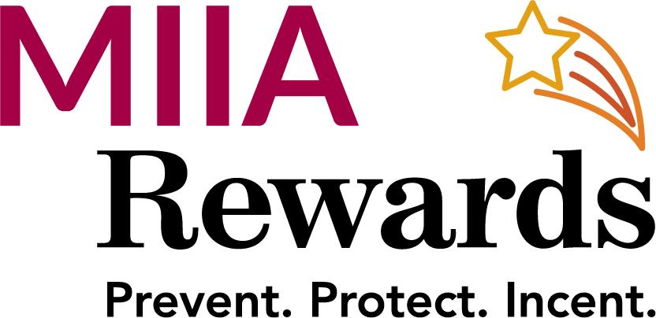
FY23 MIIA Rewards Association & Training Partner Program

The following MIIA Partner Training sessions are Approved for Rewards credit in FY 23
Credit will only be applied where attendance lists are available

Massachusetts Municipal Association (MMA)
- Suffolk Leadership Program
- Collins Institute - Fall and Spring-
- Suffolk Municipal Finance

Annual Meeting Workshops (MIIA eligible)
Massachusetts Municipal Management Association (MMMA)
- Boot Camp – Sept 2022
- Spring Conference- 6-2-22 & 6-3-22
- Fall Conference- 11-17-22
- Conflict Resolution Webinar 3-28-22

Massachusetts Municipal Human Resource Association (MMHR)
- Fall Conference- 9-14-22 & 9-15-22
- Labor Relations – 10-28-22
- Boot Camp – May 2023
- Conflict Management Webinar (with EAP) 11-2-22

Citizens Planning Training Collaborative (CPTC)
- Specific designated sessions)

Massachusetts Association of School Business Officials (MASBO)
- Specific designated sessions Only with certificate of attendance

Massachusetts Facilities Administrators Association Conferences (Workers Compensation credit)
- MFAA Annual Custodial Training and Certification Conference (April 2023)
- MFAA conference _ Worcester (November 2022) (Conference)

Massachusetts Municipal Cybersecurity Summit- (10-6-22)

