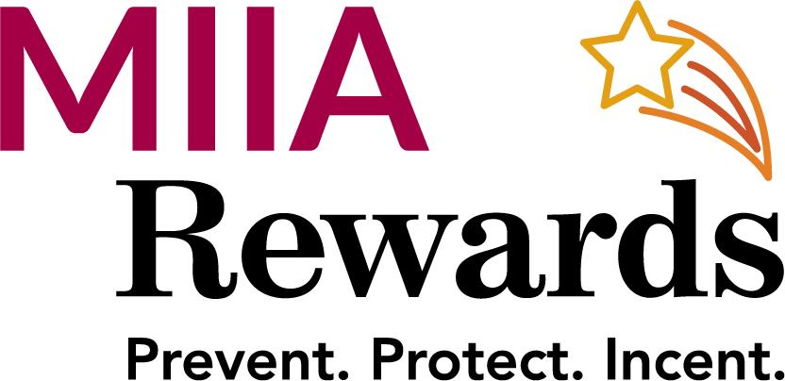
FY23 MIIA Rewards Association & Training Partner Program

The following MIIA Partner Training sessions are Approved for Rewards credit in FY 23
Credit will only be applied where attendance lists are available

Massachusetts Municipal Association (MMA)
- Suffolk Leadership Program
- Collins Institute - Fall and Spring-
- Suffolk Municipal Finance

Annual Meeting Workshops (MIIA eligible)
MIIA/MMA- Leadership 101 for New Manager

Massachusetts Municipal Management Association (MMMA)
- Boot Camp – October 2022
- Spring Conference- 6-2-22 & 6-3-22
- Fall Conference-

Massachusetts Municipal Human Resource Association (MMHR)
- Annual Meeting- 6-16-22
- Fall Conference- 9-14-22 & 9-15-22
- Labor Relations – 10-28-22
- Boot Camp

Massachusetts Select Board Administration (MSA)
- Leadership Conference- 10-22-22

Citizens Planning Training Collaborative (CPTC)
- Specific designated sessions)

Massachusetts Association of School Business Officials (MASBO)
- Specific designated sessions Only with certificate of attendance

Massachusetts Facilities Administrators Association
- MFAA Annual Custodial Training and Certification

Enquiron Webinars (Only specific designated webinars)

